NOMENCLATURE AND GRAPHIC REPRESENTATIONS FOR CHEMICALLY MODIFIED POLYMERS
(IUPAC Recommendations 201X)*

Robert B. Fox¹, Alain Fradet², Michael Hess³, Philip Hodge⁴, the late Kazuyuki Horie⁵, Richard G. Jones⁶, Jaroslav Kahovec⁷, Tatsuki Kitayama†⁸, Pavel Kratochvíl⁷, P. Kubisa⁹,
Ernest Maréchal², Werner Mormann³, Christopher K. Ober¹⁰, Robert F. T. Stepto¹¹, Michel Vert¹²,
Jiří Vohlídal¹³, Edward S. Wilks¹⁴

¹ 6115 Wiscasset Road, Bethesda, Maryland 20816, USA, ² Université Pierre et Marie Curie, Paris, France; ³ Universität Siegen, Siegen, Germany; ⁴ University of Manchester, Manchester, UK.; ⁵ University of Tokyo, Japan; ⁶ University of Kent, Canterbury, Kent, U.K.; ⁷ Academy of Sciences of the Czech Republic, Praha, Czech Republic; ⁸ Osaka University, Osaka, Japan; ⁹ Polish Academy of Sciences, Łódz, Poland; ¹⁰ Cornell University, Ithaca, NY, USA; ¹¹ University of Manchester, Manchester, UK; ¹² Université Montpellier 1, Montpellier, France; ¹³ Charles University in Praha, Faculty of Sciences, Czech Republic; ¹⁴Canterbury Hills, Hockessin, DE, U. S. A.

Abstract: A new source-based nomenclature system is described which indicates that a particular polymer has been chemically modified. A connective within the name of a polymer, -mod-, is introduced for this nomenclature as in poly[(A)-mod-(B)]. The system is intended to be used in accordance with source-based naming of polymers but also provides for the use of structure-based names when it is unavoidable. It embraces: (1) modification of a constitutional unit into another, the unique structure of which is known, and (2) a more general modification of a constitutional unit resulting in any one of a number of possible structures. In addition, a new symbol, ~>, is proposed for use in graphic representations of the structure of modified polymers.

Keywords: chemical modification; nomenclature; graphic representation; partial modification; polymer, copolymer; IUPAC Chemical Nomenclature and Structure Representation Division; IUPAC Polymer Division

CONTENTS

MP-0 PREAMBLE
MP-1 BASIC PRINCIPLES
MP-1.1 Nomenclature for Chemically Modified Polymers
MP-1.2 Graphic Representations of Chemically Modified Polymers
MP-1.3 Extent of Chemical Modification
MP-2 RULES FOR THE NOMENCLATURE AND GRAPHIC REPRESENTATION OF CHEMICALLY MODIFIED POLYMERS
MP-3 REFERENCES
MP-4 MEMBERSHIP OF SPONSORING BODIES

MP-0 PREAMBLE

Besides the many polymers that are produced by direct polymerization of monomer(s), products containing chemically modified polymers have been available for well over 80 years and continue to be commercially important. For example, the synthesis of poly(vinyl alcohol) by hydrolysis of poly(vinyl acetate) and the subsequent reaction of poly(vinyl alcohol) with benzaldehyde to form cyclic acetal units both date from 1924, while the first patents claiming chlorosulfonated polyethylene and chlorinated polyethylene date from 1940 and 1956, respectively.
Nomenclature procedures for modified polymers have traditionally considered the reactant and product to be separate entities, each named according to existing IUPAC recommendations [1-11]. Thus, when a fraction of the constitutional units, A, of poly(A) is transformed into a new one, J, that is, partial modification of A into J, the reactant would be named poly(A), and the product would be named as a copolymer, poly[(A)-co-(J)], as though it had been formed by copolymerization of monomers A and J [6]. While this is fundamentally correct, it can commonly be tedious; the longer the names of the constitutional units, or the more types of units there are in a copolymer, or both, the more onerous the task becomes. Additionally, sequence distributions within a chemically modified polymer can be different from those formed by copolymerization. It is also important to draw the distinction between chemical modification of a preformed polymer and copolymerization but, because there are no standards for either nomenclature or graphic representation of the former, scientists often use impromptu notations that may be subject to misinterpretation by others.
Within the established IUPAC nomenclature for polymers, comprehensive source-based or structure-based systematic nomenclature systems for dealing with modified polymers have been neglected. Some structure-based names, typically for chlorinated polyethylene, are cited in an earlier IUPAC document [8], and, though this was not primarily written to address nomenclature for modified polymers, its recommendations are of relevance in the present context.
This document provides a new naming system and graphic representation to cover polymers that have been chemically modified within either their backbone or pendent group structures, or both.
In the broadest sense, the term ‘modified polymers’ could also be interpreted to include other types such as comb polymers, graft polymers and polymer networks but these are excluded from consideration here. Also, though chemical transformation of a polymer may involve modification of its end-groups, the new system does not seek to cover the naming of modified end-groups. If needed and relevant, the names of end-groups should follow the established recommendations [2, 8].

MP-1 BASIC PRINCIPLES

MP-1.1 Nomenclature for Chemically Modified Polymers
This document presents a faster and more compact method of conveying standard information for both partly and completely modified polymers by incorporating within a single name an indicator of the chemical modification. To that end, a new connective, -mod-, an abbreviation of the phrase ‘modified to’, is introduced to indicate chemical modification of the structure of the constitutional units of a polymer. Thus, a typical representation of the name of a modified polymer would be poly[(A)-mod-(J)] resembling that of the source-based name of a copolymer, poly[(A)-co-(J)]. In fact, the product of partly modified poly(A) is a copolymer but the name poly[(A)-mod-(J)] conveys the information that a polymer was made from poly(A) by forming new constitutional units J through the chemical modification of constitutional units A. In contrast, the name poly[(A)-co-(J)] only indicates that there are two types of constitutional unit present in the polymer, though it is commonly inferred that this results from copolymerization.
In all other respects, the naming of copolymers resulting from partial modification should be done in accordance with existing IUPAC recommendations [6,8] with the names of each new constitutional unit together with those of the unmodified ones being incorporated into the complete name of the polymer (the naming of irregular polymers or copolymers that result from multistep modification reactions is enabled by extending the recommended system as elaborated in Section MP-2). In cases where this is not feasible because J cannot be identified explicitly, the method is adapted to provide as much information as possible; for example, information may be added about any new substituent(s) that are attached to the original polymer. Thus, if J is a well-characterized constitutional unit with an exclusive structural representation, then its IUPAC name should be used. Typically, the partial hydrolysis of poly(vinyl acetate) converts some vinyl acetate units to vinyl alcohol units and the modified polymer can be named poly[(vinyl acetate)-mod-(vinyl alcohol)]. On the other hand, there are reactions that can lead to a variety of structures for modified constitutional units in a seemingly unselective manner, for example, the chlorination of poly(4-methylstyrene) may result in the replacement with chlorine atoms of up to six of the non-aromatic hydrogen atoms on any given constitutional unit. The modified unit could then be any one of many structures and to name them all would be cumbersome. In such a situation, they can be named as a family by association of poly(A) with the name of the new substituent, which in this instance is chloro, and the polymer would be [poly(4-methylstyrene)]-mod-chloro or, in general, [poly(A)]-mod-J.

Within a complete name of a modified polymer source-based or structure-based nomenclature styles can be used for A and J, and although it is not elaborated herein, the principles can be extended to the use of the generic source-based nomenclature style. Since a modified polymer is sourced from a precursor polymer, which in turn has been sourced from monomer(s), for the sake of consistency the source-based naming system is preferred. However, following modification the polymer often has no appropriate source-based name. In such instances, structure-based names can be used for A and J but should accord with established rules for naming irregular single-strand organic polymers [8] which preclude the use of connectives such as -co- and -mod- requiring instead a solidus, /. Thus, the structure-based equivalent of poly[(A)-mod-(J)] is poly[(A)/(J)]. For modified polymers of the [poly(A)]-mod-J type, since the nomenclature style of choice can only be applied to the precursor polymer, poly(A), which is then isolated by containment within brackets, the use of the -mod- connective is recommended in either case.
Many polymer modification reactions involve complex reagents and lead to even more complex structures. Consequently, the use of systematic names is not always practical. In such situations, but only in such situations, traditional names of polymers and non-systematic names retained within general nomenclature for substituents resulting from modification are sanctioned for use within the source-based system.
In the examples of polymer names in this document, source-based names are given first and structure-based names, where practical, are added as alternatives. Where the latter appear in pairs, the first is the preferred name though either is allowed.
The same nomenclature style should be used throughout a complete polymer name.

MP-1.2 Graphic Representations of Chemically Modified Polymers
To provide additional comprehension, for modified polymers of the poly[(A)-mod-(J)] type each example in this document includes a graphic representation in which a tilde is used in conjunction with a ‘greater than’ symbol to form a ‘wavy arrow’, ‘~>’. It is not to be identified as a reaction arrow but as a separator of different constitutional units in an overall structure as is the solidus used in the graphic representation of an irregular polymer [12], (-A- / -B-) _{n}. The solidus used within the graphic representation of an irregular polymer has no implied directionality for the order of citation of the constitutional units therein is arbitrary. However, polymer modification is direction specific and the order of citation is critical and the ‘~>’ symbol reflects this. Thus, (-A- ~> -J-) correctly indicates that some units A have been modified to units J whereas (-J- ~> -A-) would incorrectly indicate that some units J have been modified to units A.
The ‘~>’ usage can also be applied to modified copolymers but it is not applicable to polymers of the [poly(A)]-mod-J type for which precise structures are not known. All other aspects of graphic representation should follow the guidelines in ref. 12.

MP-1.3 Extent of Chemical Modification
In general, for polymers of the poly[(A)-mod-(J)] type, when their composition is known the IUPAC recommendation is that they should be identified as copolymers and named as such with their compositions appended as mass %, mole %, or mol fraction, etc., as elaborated in section 8 of ref. 6. However, when the representation of chemical modification is deemed to be essential then compositional information can in an exactly analogous way be appended to the name or graphic representation of a modified polymer. Likewise, for polymers the constitutional units of which have all been modified the IUPAC recommendation is that the original constitutional unit(s) should not be cited in the name; in other words, poly(A) that is deemed to have been completely modified to poly(J) should simply be called poly(J) but if for whatever reason it is considered desirable to use the ‘-mod-’ nomenclature, the same method of appending compositional information can be applied. Typically, 0:100 mol % might be appended to the name or graphic representation to distinguish the product from the same polymer prepared by an alternative method such as direct synthesis from the corresponding monomer. Such an expedient might also be extended to additional information concerning properties such as the degree of polymerization, dispersity, regiochemistry and stereochemistry which might or might not be affected by the modification.

For modified polymers for which precise structural information is not available, which include those of the [poly(A)]-mod-J type, if it is required to represent the extent of modification then it is recommended that ‘x mass %’ is used in conjunction with an indicator of an element or group that characterizes the modification, e.g., Br or NO₂ respectively for polymers modified by bromination or nitration, typically (polyethene)-mod-bromo (15 mass % Br).

MP-2 RULES FOR THE NOMENCLATURE AND GRAPHIC REPRESENTATION OF CHEMICALLY MODIFIED POLYMERS
Rule 1
When some constitutional units A of a homopolymer, poly(A), are converted to new constitutional units J, K, L, etc., the name of the modified polymer is

poly[(A)-mod-(J);(K);(L); …]

for which the graphic representation is

(-A- ~> -J-/-K-/-L-/…)_{n} .
Note: If the new constitutional units result from successive modifications they should be cited in that order, if not, they should be cited in alphabetical order. In either case, within the complete polymer name the names of the modified units should be separated by semicolons without spaces.

Example 1: Partly hydrolyzed poly(methyl acrylate)

Names:
source-based: poly[(methyl acrylate)-mod-(acrylic acid)]

structure-based: poly{[1-(methoxycarbonyl)ethylene]/(1-carboxyethylene)}
poly{[1-(methoxycarbonyl)ethane-1,2-diyl]/(1-carboxyethane-1,2-diyl)}

Graphic Representation:
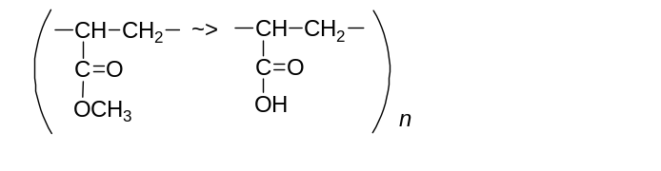
Example 2: Partly hydrolyzed poly(vinyl acetate)
Names:
source-based: poly[(vinyl acetate)-mod-(vinyl alcohol)]
structure-based: poly[(1-acetoxyethylene)/(1-hydroxyethylene)]
poly[(1-acetoxyethane-1,2-diyl)/(1-hydroxyethane-1,2-diyl)]
Graphic representation:
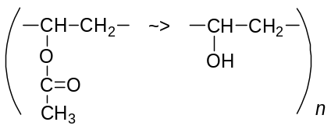

Example 3: Poly(trimethylsilyl vinyl ether) completely converted into poly(vinyl alcohol).
Names:
source-based: poly(vinyl alcohol)
poly[(trimethylsilyl vinyl ether)-mod-(vinyl alcohol)] (0:100 mol %)
structure-based: poly(1-hydroxyethylene)
poly(1-hydroxyethane-1,2-diyl)
Graphic representation:
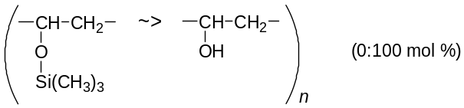

Example 4: Neighbouring vinyl alcohol constitutional units in poly(vinyl alcohol) partly cyclized by reaction with benzaldehyde to (2-phenyl-1,3-dioxane-4,6-diyl)methylene constitutional units.
Note: If neighbouring groups in a polymer chain are both required for a given modification as is the case for this example, then for statistical reasons 100 % conversion is not possible [13].
Names:
source-based: poly{(vinyl alcohol)-mod-[bis(ethenyloxy)methyl]benzene}
structure-based: poly[(1-hydroxyethylene)/(2-phenyl-1,3-dioxane-4,6-diyl)methylene]
poly[(1-hydroxyethane-1,2-diyl)/(2-phenyl-1,3-dioxane-4,6-diyl)methylene]

Graphic representation:
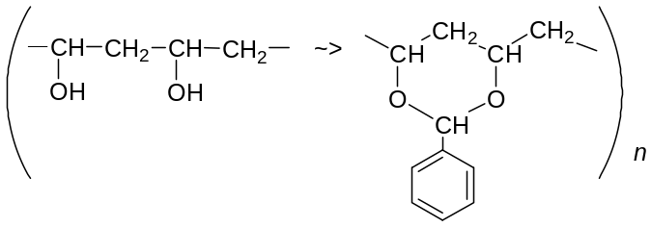
Example 5. Linear polyacrylonitrile partly converted to ladder-polyacrylonitrile.
Names:
source-based: poly(acrylonitrile-mod-ladder)
structure-based: poly[(1-cyanoethylene)/(1-azabut-1-ene-1,4:3,2-tetrayl)]
poly[(1-cyanoethane-1,2-diyl)/(1-azabut-1-ene-1,4:3,2-tetrayl)]

Graphic representation:
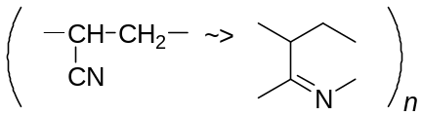

Example 6. Poly(1,3,4-oxadiazole-2,5-diyl-1,4-phenylene) partly converted to a linear polyhydrazide.
Names:
structure-based: poly[1,3,4-oxadiazole-2,5-diyl-1,4-phenylene/carbonyl(1-methylhydrazine-1,2-diyl)carbonyl-1,4-phenylene]

Graphic representation:
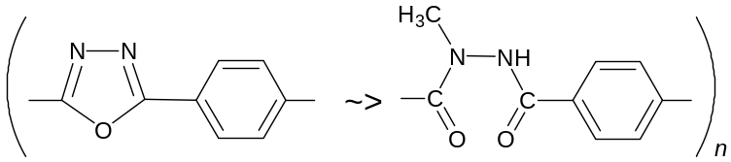

Example 7. Poly(methacrylic acid) partly esterified with a mixture of ethanol and methanol to give a polymer containing ethyl methacrylate and methyl methacrylate units.

Names:
source-based: poly[(methacrylic acid)-mod-(ethyl methacrylate);(methyl methacrylate)]
structure-based: poly[(1-carboxy-1-methylethylene)/(1-ethoxycarbonyl-1-methylethylene)/(1-methoxycarbonyl-1-methylethylene)]
poly[(1-carboxy-1-methylethane-1,2-diyl)/(1-ethoxycarbonyl-1-methylethane-1,2-diyl)/(1-methoxycarbonyl-1-methylethane-1,2-diyl)]

Graphic representation:
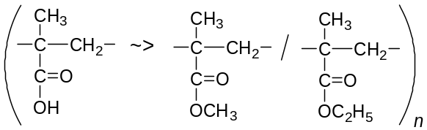

Example 8. Poly(benzyl β-malolactonate) completely converted to poly(malic acid)

Names:
source-based: poly{3-[(benzyloxy)carbonyl]-3-hydroxypropanoic acid}
poly({3-[(benzyloxy)carbonyl]-3-hydroxypropanoic acid}-mod-(hydroxybutanedioic acid)) (0:100 mol %)

structure-based: poly(oxy(1-carboxy-3-oxopropane-1,3-diyl)

Graphic representation:
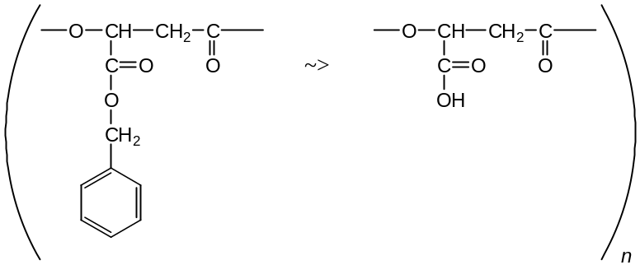

Example 9. Poly(malic acid) partly modified by reaction with (1) doxorubicin and (2) aminofluorescein to a product comprising 30 mol % of modified units (1) and 10 mol % of modified units (2).

Name:
source-based: poly{(malic acid)-mod-(N-doxorubicinylmalamide);(N-fluoresceinylmalamide)} (60:30:10 mol %)

Graphic representation:
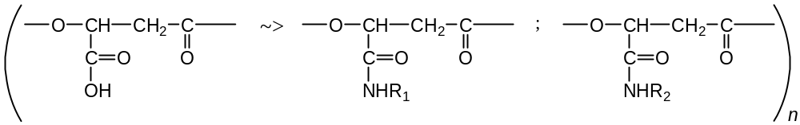 (60:30:10 mol %)
in which R₁ and R₂ are defined as follows:
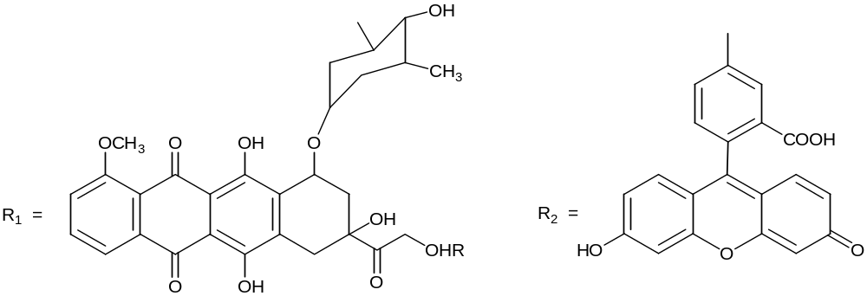

Note: By using the non-systematic names, malic acid, malamide, doxorubicin, aminofluorescein, etc. for reactants and substituents, this example illustrates the practicality of allowing their use within the source-based system for naming modified polymers. Without such an exception, for general usage the naming of such polymers would be beyond the bounds of practicality and for the same reason it is appropriate to abbreviate the corresponding graphic representation.

Rule 2
When some constitutional units A, B, C, etc., of a copolymer, poly[(A)-co-(B)-co-(C)-..], are respectively converted to new constitutional units J, K, L, etc., the name of the modified polymer is

poly{[(A)-mod-(J)]-co-[(B)-mod-(K)]-co-[(C)-mod-(L)]-…..}

for which the graphic representation is

[(-A- ~> -J-)/(-B- ~> -K-)/(-C- ~> -L-)…]_{n} .

Example 10. Partly hydrolyzed poly[(methyl acrylate)-co-styrene]
Names:
source-based: poly{[(methyl acrylate)-mod-(acrylic acid)]-co-styrene}
structure-based: poly{[1-(methoxycarbonyl)ethylene]/(1-carboxyethylene)]/1-phenylethylene}
poly{[1-(methoxycarbonyl)ethane-1,2-diyl]/(1-carboxyethane-1,2-diyl)]/1-phenylethane-1,2-diyl}

Graphic representation:
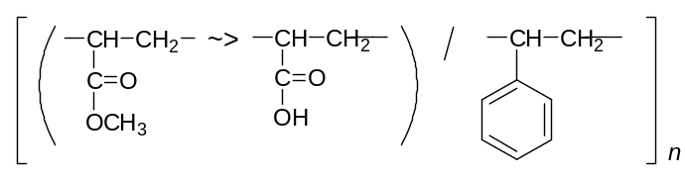

Example 11. A copolymer comprising units derived from the 1,4 polymerization of buta-1,3-diene and styrene, partly hydrogenated in the chain.

Names:
source-based: poly{[(buta-1,3-diene)-mod-ethene]-co-styrene}

structure-based: poly{[(butane-1,4-diyl)/(but-1-ene-1,4-diyl)]/(1-phenylethylene)}
poly{[(butane-1,4-diyl)/(but-1-ene-1,4-diyl)]/(1-phenylethane-1,2-diyl)}

Graphic representation:
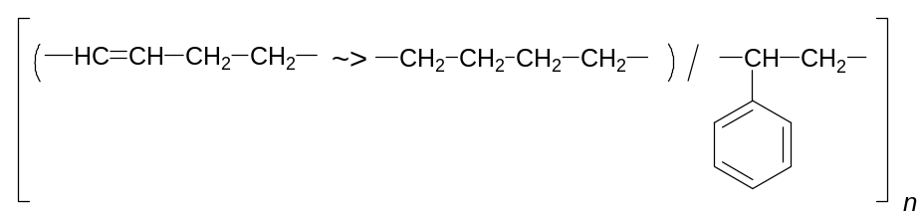
Example 12. Partly hydrolyzed poly[(isopropenyl acetate)-co-(methyl acrylate)]
Names:
source-based: poly{[(isopropenyl acetate)-mod-(isopropenyl alcohol)]-co-[(methyl acrylate)-mod-(acrylic acid)]}
structure-based: poly{[(1-acetoxy-1-methylethylene)/(1-hydroxy-1-methylethylene)]/[1-(methoxycarbonyl)ethylene]/(1-carboxyethylene)}
poly{[(1-acetoxy-1-methylethane-1,2-diyl)/(1-hydroxy-1-methylethane-1,2-diyl)]/[1-(methoxycarbonyl)ethane-1,2-diyl]/(1-carboxyethane-1,2-diyl)}

Graphic representation:
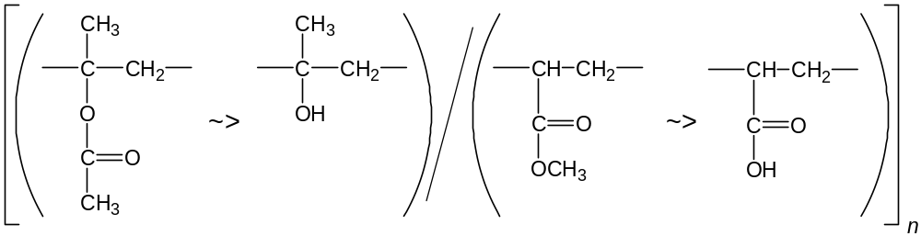

Example 13. Poly(acrylonitrile-co-styrene) in which acrylonitrile units are partly converted to vinyl tetrazole units.
Names:
source-based: poly{[acrylonitrile-mod-(5-vinyl-1H-tetrazole)]-co-styrene}
structure-based: poly({[(1-cyanoethylene)/[1-(1H-tetrazol-5-yl)ethylene]}/1-phenylethylene)
poly({[(1-cyanoethane-1,2-diyl)/[1-(1H-tetrazol-5-yl)ethane-1,2-diyl]}/1-phenylethane-1,2-diyl)

Graphic representation:
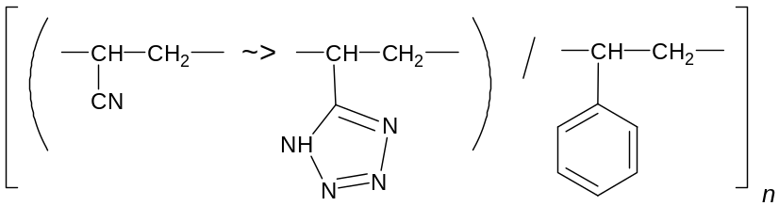

Example 14. Poly[ethene-co-(methacrylic acid)] partly neutralized to form sodium methacrylate units.
Names:
source-based: poly{ethene-co-[(methacrylic acid)-mod-(sodium methacrylate)]}
structure-based: poly{methylene/[(1-carboxy-1-methylethylene)/(sodium 1-carboxylato-1-methylethylene)]}
poly{methylene/[(1-carboxy-1-methylethane-1,2-diyl)/(sodium 1-carboxylato-1-methylethane-1,2-diyl)]}

Graphic representation:
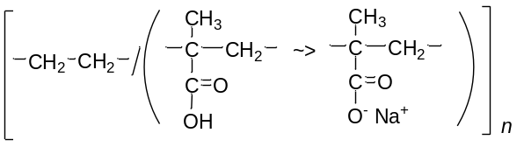
Rule 3
When some constitutional units A, B, C, etc. of a copolymer, poly[(A)-co-(B)-co-(C)-…..], are converted to a new constitutional unit J, the name of the modified polymer is

poly{[(A)-co-(B)-co-(C)-…..]-mod-(J)}

for which the graphic representation is

(-A-/-B-/-C-/… ~> -J-)_{n} .

Example 15. Partly hydrolyzed copolymer of methyl methacrylate and ethyl methacrylate
Names:
source-based: poly{[(methyl methacrylate)-co-(ethyl methacrylate)]-mod-(methacrylic acid)}
structure-based: poly{[1-(methoxycarbonyl)-1-methylethylene]/[1-(ethoxycarbonyl)-1-methylethylene]/(1-carboxy-1-methylethylene)}
poly{[1-(methoxycarbonyl)-1-methylethane-1,2-diyl]/[1-(ethoxycarbonyl)-1-methylethane-1,2-diyl]/(1-carboxy-1-methylethane-1,2-diyl)}

Graphic representation:
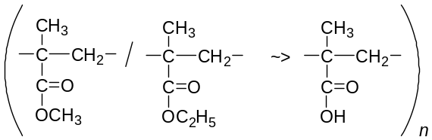

Rule 4
When some constitutional units, A, of a homopolymer, poly(A), are changed by introduction of substituents, J_{j}, J_{k}, J_{l}, etc., at unspecified positions through successive modifications, the name of the polymer is
[poly(A)]-mod-J_{j}-mod-J_{k}-mod-J_{l};….

Note: Either nomenclature style, source-based or structure-based, can be used for poly(A).

Example 16. Polyethene chlorinated to give a product containing an unspecified amount of chlorine.
Names:
(polyethene)-mod-chloro or [poly(methylene)]-mod-chloro

Note: Refs. 8 and 12 include examples (7.1 and 3-E2 respectively) which give the structure-based name of this irregular polymer as poly(chloromethylene/dichloromethylene/methylene). For reasons of brevity, the nomenclature recommended here is better suited for such cases.

Example 17. Chlorinated polyethene containing 32 mass % of chlorine.

Names:
(polyethene)-mod-chloro (32 mass % Cl) or [poly(methylene)]-mod-chloro (32 mass % Cl)

Example 18. Polystyrene brominated to give a product containing 24 mass % of bromine present at unknown locants on both the phenyl rings and the backbone.

Names:
(polystyrene)-mod-bromo (24 mass % Br) or [poly(1-phenylethylene)]-mod-bromo (24 mass % Br) or [poly(1-phenylethane-1,2-diyl)]-mod-bromo (24 mass % Br)

Note: If polystyrene is brominated to introduce one or more bromine atoms at known positions, the new constitutional units may be named ‘x-bromostyrene’, ‘x,y-dibromostyrene’, etc., in the source-based system, and the modified polymers should be named poly[styrene-mod-x-bromostyrene)], poly[styrene-mod-x, y-dibromostyrene)], etc., in which x, y, etc., represent 2-, 3-, 4-, α- or β-.

Example 19. Polysulfone (I) nitrated to give a product containing 5.6 mass % of nitro groups at unspecified positions.
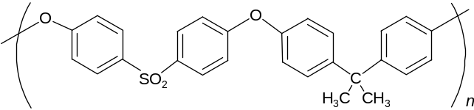 (I)
Name:
{poly[oxy-1,4-phenylenesulfonyl-1,4-phenyleneoxy-1,4-phenylene(dimethylmethylene)-1,4-phenylene]}-mod-nitro (5.6 mass % NO₂)

Example 20. Polyethene chlorinated then brominated.

Names:
(polyethene)-mod-chloro-mod-bromo or [poly(methylene)]-mod-chloro-mod-bromo

Rule 5
When some constitutional units, A, of a homopolymer, poly(A), are changed by introduction of substituents, J_{j}, J_{k}, J_{l}, etc., at unspecified positions through simultaneous modifications, the name of the polymer is
[poly(A)]-mod-J_{j};J_{k};J_{l};….

Note 1: Either nomenclature style, source-based or structure-based, can be used for poly(A).
Note 2: The new substituents should be cited in alphabetical order separated by semicolons without spaces
.
Example 21. Polyethene chlorosulfonated to unknown degrees of chlorination and chlorosulfonation.

Names:
(polyethene)-mod-chloro;chlorosulfonyl or [poly(methylene)]-mod-chloro;chlorosulfonyl

Note: Simultaneous chlorination and chlorosulfonation of polyethylene is capable of generating 18 new constitutional units, thus, the compact names shown here are recommended as a practical solution to an otherwise difficult nomenclature problem.

Rule 6
When one of the constitutional units A, B, C, etc., of a copolymer, poly[(A)-co-(B)-co-(C)-….], is changed by introduction of a new substituent, J, at unspecified positions, the name of the polymer is

poly{[(A)-mod-J]-co-(B)-co-(C)-….}

Note: Either nomenclature style, source-based or structure-based, can be used for poly(A).

Example 22. Poly[styrene-co-(methyl methacrylate)] treated with bromine/AlBr₃.
Names:
poly{[(styrene)-mod-bromo]-co-(methyl methacrylate)} or poly{[(1-phenylethylene)-mod-bromo]/(1-methoxycarbonyl-1-methylethylene)} or poly{[(1-phenylethane-1,2-diyl)-mod-bromo]/(1-methoxycarbonyl-1-methylethane-1,2-diyl)}

MP-3 REFERENCES
- IUPAC Recommendations 2008. Compendium of Polymer Terminology and Nomenclature. Prepared for publication by R. G. Jones, J. Kahovec, R. Stepto, E. S. Wilks, M. Hess, T. Kitayama, W. V. Metanomski, with advice from A. Jenkins and P. Kratochvíl, RSC Publishing, Cambridge, UK (2008).
- Chapter 14, 261-279 in ref.1
- IUPAC. Nomenclature of regular single-strand organic polymers, Pure Appl. Chem. 74, 1921-1956 (2002). Reprinted as Chapter 15 in ref. 1
- IUPAC. A classification of linear single-strand polymers. Pure Appl. Chem. 61, 243-254 (1989).
- IUPAC. Nomenclature for regular single-strand and quasi-single-strand inorganic and coordination polymers. Pure Appl. Chem. 57, 149-168 (1985).
- IUPAC. Source-based nomenclature for copolymers. Pure Appl. Chem. 57, 1427-1440 (1985). Reprinted as Chapter 20 in ref. 1.
- IUPAC. Nomenclature of regular double-strand (ladder and spiro) organic polymers. Pure Appl. Chem. 65, 1561-1580 (1993). Reprinted as Chapter 16 in ref. 1.
- IUPAC. Structure-based nomenclature for irregular single-strand organic polymers. Pure Appl. Chem. 66, 873-889 (1994). Reprinted as Chapter 17 in ref. 1.
- IUPAC. Source-based nomenclature for non-linear macromolecules and macromolecular assemblies. Pure Appl. Chem. 69, 2511-2521 (1997). Reprinted as Chapter 21 in ref. 1.
- IUPAC. Generic source-based nomenclature for polymers. Pure Appl. Chem. 73, 1511-1519 (2001). Reprinted as Chapter 22 in ref. 1.
- IUPAC. (a) Nomenclature of Organic Chemistry, Sections A, B, C, D, E, F and H, Pergamon Press, Oxford (1979); (b) IUPAC. A Guide to IUPAC Nomenclature of Organic Compounds. Blackwell Scientific Publications, Oxford (1994); (c) Pure Appl. Chem., 1999, 71, 1327 – 1330; (d) Nomenclature of Inorganic Chemistry, IUPAC Recommendations 2005, RSC Publishing, Cambridge (2005).
- IUPAC. Graphic representations (chemical formulae) of macromolecules. Pure Appl. Chem. 66, 2469-2482 (1994); Reprinted as Chapter 21 in ref. 1.
- P.J. Flory, J. Amer. Chem. Soc., 61, 1518-1521, 1939

MP-4 MEMBERSHIP OF SPONSORING BODIES
Membership of the IUPAC Chemical Nomenclature and Structure Representation Division for the period 2010–2013 was as follows:
President: R. M. Hartshorn (New Zealand); Secretary: T. Damhus (Denmark); Past President: G. P. Moss (UK); Titular Members: J. Brecher (USA); K. Degtyarenko (UK); P. Hodge (UK); A. T. Hutton (South Africa); L. G. Jeffery (UK); J. Wilson (USA), A. Yerin (Russia); Associate Members: K.-H. Hellwich (Germany); J. Kahovec (Czech Republic); E. Nordlander (Sweden); J. Nyitrai (Hungary); W. H. Powell (USA); J. Reedijk (Netherlands); National Representatives: S. Baskaran (India); M. A. J. Miah (Bangladesh); P. Moyna (Uruguay); H. Ogino (Japan); R.F. Pellón (Cuba); A. P. Rauter (Portugal); R. B. de Alencatro (Brazil).

Membership of the IUPAC Polymer Division Committee for the period 2010–2013 was as follows:
President: C. K. Ober (USA); Vice President: M. Buback (Germany); Secretary: M. Hess (Germany); Past President: J.-I. Jin (Korea); Titular Members: T. Chang (Korea); R. G. Jones (UK); S. Penczek (Poland); G. T. Russell (New Zealand); M. Sawamoto (Japan); R. F. T. Stepto (UK), J.-P. Vairon (France); Associate Members: S. C. Kim (Korea); T. Kitayama (Japan); P. Kubisa (Poland); W. Mormann (Germany); J. Stejskal (Czech Republic); M. Vert (France); National Representatives: D. Berek (Slovakia); D. J. Dijkstra (Germany); G. Galli (Italy); J. K. Kallitsis (Greece); Z.-C. Li (China); G. Moad (Australia); M. Raza Shah (Pakistan); R. Prakesh Singh (India); J. Vohlídal (Czech Republic); M. Žigon (Slovenia).

The name of a homopolymer is made by prefixing the monomer name with “poly”. The name of the monomer is parenthesized if it consists of more than one word, or it contains one or more locants or stereodescriptors, or ambiguity in meaning can arise. Given that this is most commonly the case, the general notation adopted in this document includes such parentheses.
N.B. chemical reactions on polymers rarely proceed to 100% conversion, an extent of reaction that is difficult to prove.

